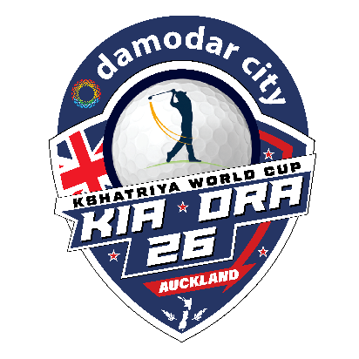

Damodar City - Kia Ora 26

Golf Tournament

Introduction
The upcoming Damodar City - Kia Ora 26 Golf Tournament in April 2026 marks a significant change from previous events. In the past, golf was featured merely as an “add on” sport alongside the soccer world cup. However, next year brings a fresh approach to the competition.

Event Details
This event will be conducted under the newly approved KISA Golfing Regulations & Format document, ensuring a dedicated and structured framework for participants and organisers alike. Below is a summarised version of this document.
KISA has established a comprehensive set of standardized golf regulations and tournament formats to align with its core values, promote fair competition, and recognize excellence both individually and by district teams. These rules ensure inclusivity for players of various skill levels while maintaining adherence to official golf standards.
- Purpose of Regulations: The document sets a uniform golf format and rules that align with KISA's mission, support diverse skill levels, and provide criteria for individual and team awards.
- Committee and Participation: The KISA Golf Consulting Committee consists of representatives from select districts, some districts declined participation.
- Tournament Structure: The event is a single-day, 18-hole competition with a minimum age of 14, default and maximum handicaps set at 18 and 27 respectively, and teams composed of four players per district, with provisions for merging players if needed.
- Awards and Recognition: Individual awards include highest Stableford points, lowest strokes, longest drive, and nearest to the pin, while team awards recognize winning and runner-up teams based on aggregate Stableford points.
- Conduct and Compliance: Caddies and spectators are prohibited except for designated officials; players must exhibit proper etiquette and respect; violations can lead to penalties to ensure fairness and professionalism.
- Official Rules and Format: The tournament follows R&A golf rules with Stableford scoring, local club regulations, and restrictions on clubs, balls, and equipment; penalties for slow play and strict adherence to rulings are enforced.
- Team and Individual Play: Teams must register four members with handicaps and birthdates; players follow "ready golf" principles, have a maximum of eight strokes per hole, and scorekeeping is done by opposing district players to ensure accuracy.
- Event Management: The host committee organizes draws, score submissions, and enforces rules including disqualification for misconduct; late arrivals join in-progress groups with missed holes scored zero.
- Handling Interruptions: In case of rain suspensions, scoring adjustments are made based on holes played, with formulas to prorate points for incomplete rounds; decisions to continue or abandon play are at the host committee's discretion.

Brief Tournament Details
As advised in earlier communications, the Golf Tournament will be played at Maungakiekie Golf Club on Wednesday 22nd April 2026.
Link: https://www.maungakiekiegolf.co.nz/
Trophies will be presented to the following winners:
- Winning Team – Highest combined 4 person team aggregate Stableford points
- Runner Up Team – 2nd highest combined 4 person team aggregate Stableford points
- Highest Stableford Points – Individual
- Lowest Strokes off the sticks - Individual
- Longest Drive - Individual
- Nearest to the Pin - Individual
Play will begin simultaneously at 12:00 pm, with groups teeing off from both the 1st and 10th holes. The tournament can accommodate up to 60 players, a cap set to ensure all rounds are finished by 6:00 pm given the available timeframe.
Individual registration forms will be released in January and will remain open until the end of February, or until 60 eligible registrations have been received, whichever comes first.
Each district is permitted to register only a single team, consisting of four players who must complete individual registrations. Team registration forms must be submitted no later than two weeks before the tournament commencement date.
Please note that players competing as part of a team are also eligible to receive individual awards. Participation in the team event does not exclude anyone from consideration for individual honours.
We expect all teams to wear polo shirts in their respective district colours during play. However, individual participants who are not part of a team are not required to adhere to this dress code. Please note that, as hosts, we will not be supplying polo tee shirts for the tournament. Participants are kindly asked to make their own arrangements regarding attire.
Additional information regarding the tournament will be shared in upcoming updates.

